Virginia Department of Education

2020 GRANVILLE P. MEADE SCHOLARSHIP APPLICATION

SECTION I: Applicant and School Information
(To be completed by applicant)

Please clearly print or type the following information:

Last Name: First: Middle:

Home Address: Phone No.:

City/County: State: Zip Code:

Social Security No. (Last 4 digits only):

Place of Birth (city and state): Date of Birth:

High School Now Attending (if applicable):

School Address: School Phone No.:

City/County: State: Zip Code:

Name of School Division (if applicable):

Name of Principal/Head of School (if applicable):

Graduation Date: Class Rank: (if applicable): No. in Class:

SAT/ACT (score): When Taken:

Name of College/University in which the Applicant Expects to Enroll:
Address of College/University: City/County: VA: Zip Code:

Career Objective (Doctor, Engineer, Lawyer, Teacher, etc.):

SECTION II: Student Essay
(To be completed by applicant)

- Please list any extracurricular activities you are involved in or honors you have received during your high school career. Including but not limited to awards, athletics, club membership, community service or volunteer work, and/or work experiences:

- Why do you desire to attend college? (Please limit your response to 550 words or less).

- Have you received other scholarships?

Scholarship: Amount Awarded:

Scholarship: Amount Awarded:

Scholarship: Amount Awarded:

Scholarship: Amount Awarded:

By signing below, I certify all information included in this application is truthful and accurate to the best of my knowledge.

Applicant’s Signature, Date

SECTION III: Family Information
(To be completed by parent or guardian)

If either or both parents are deceased, please indicate:

Information of Parent/Guardian completing Section II, pages 6-7.

Parent/Guardian Name: Age:

Address:

City/County: State: Zip Code:

Occupation: Approximate Annual Income:

Parent/Guardian Name: Age:

Address:

City/County: State: Zip Code:

Occupation: Approximate Annual Income:

Parent/Guardian Name: Age:

Address:

City/County: State: Zip Code:

Occupation: Approximate Annual Income:

Parent/Guardian Name: Age:

Address:

City/County: State: Zip Code:

Occupation: Approximate Annual Income:

Number of family members (other than any adults identified above and the applicant):

Ages: Number presently attending college:
Number who are self-supporting:

SECTION IV: Financial Information
(To be completed by parent or guardian)

Estimated amount parents or guardians can provide annually toward applicant’s college expense:

Amount that may be available annually from other sources:

Other relatives: Amount:

Trust funds: Amount:

Applicant’s savings: Amount:

Applicant’s summer employment: Amount:

Any other: Amount:

Are there any unusual circumstances that curtail the family income or increase the family expenses? (Please explain in detail).

By signing below, I certify all information included in this application is truthful and accurate to the best of my knowledge.

Parent/Guardian’s Signature, Date

SECTION V- Attachments
In addition to the information in sections I and IV, submitted applications must contain the following documents:

Three confidential reference letters from individuals not related to the applicant including the applicant’s high school principal or head of school (if applicable). These letters should give specific information in regards to:
- The applicant’s character, personality, and ability,
- Particular reference must be made to the applicant’s need and the family’s financial ability, and
- Contact information for the author of the letter.

An official high school transcript

Standardized test record

*Home-schooled students: For sections not applicable, insert “N/A.”

The Virginia Department of Education does not discriminate on the basis of race, sex, color, national origin, religion, age, political affiliation, veteran status, or against otherwise qualified persons with disabilities in its programs and activities and provides equal access to the Boy Scouts and other designated youth groups. The following position has been designated to handle inquiries regarding the Department’s non-discrimination policies:
Deputy Superintendent – Finance and Operations
Virginia Department of Education
P.O. Box 2120
Richmond, Virginia 23218-2120
Phone: (804) 225-2025
For further information on Federal non-discrimination regulations, contact the Office for Civil Rights at OCR.DC@ed.gov or call 1-800-421-3481.
You may also view Governor Terry McAuliffe’s Executive Order 1 (EO-1, 2014), which specifically prohibits discrimination on the basis of race, sex, color, national origin, religion, age, political affiliation, or against otherwise qualified persons with disabilities. The policy permits appropriate employment preferences for veterans and specifically prohibits discrimination against veterans.

Application procedure overview:
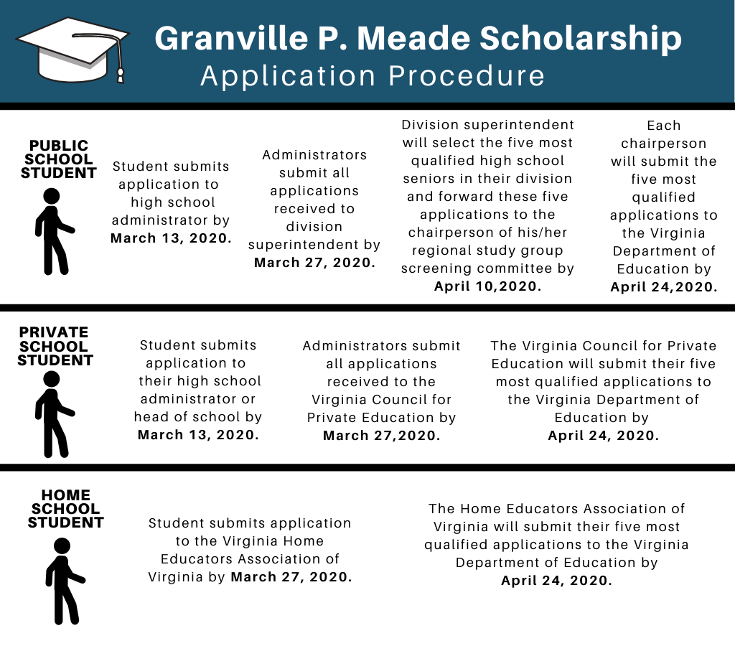

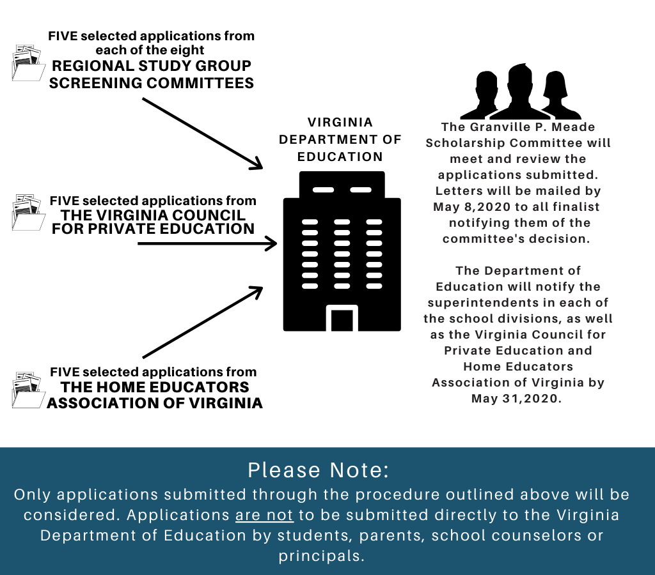

Public School Application Contact

Application questions can be directed to Sarah Bazemore, School Counseling Specialist at the Virginia Department of Education (VDOE) by telephone, at 804-225-4024, or by email at Sarah.Bazemore@doe.virginia.gov.

Homeschool Application Contact

Homeschool application questions can be directed to the VDOE (see contact information above) or to the Homeschool Educator’s Association designated chair Ms. Yvonne Bunn, by telephone at 804-278-9200, or by email at support@heav.org.

Homeschool applications are to mail their applications to the following address:
Homeschool Educator's Association of Virginia
Attn: Granville P. Meade Scholarship Chair
2100 W. Laburnum Avenue
Suite 108-A
Richmond, Virginia 23227

Private School Application Contact
Private school application questions can be directed to the VDOE (see contact information above) or to the Virginia Council for Private Education’s designated chair, Ms. Grace Turner Creasey, by telephone at 804-423-6435, or by email at gpmeade@vcpe.org.

Private school administrators or heads of school are to mail their applications to the following address:
Virginia Council for Private Education
Attn: Granville P. Meade Scholarship Chair
P.O. Box 29255
Richmond, Virginia 23242

