Request for Nominations
2019
New River Community Action’s
Rev. George Ducker Scholarship Award
In memory of the Reverend George L. Ducker, member of the New River Community Action Board of Directors 1986-1992, Pastor of the Presbyterian Church of Radford, Radford City School Board and United Way Board member, community leader and advocate of quality education for all.
ALL ENTRIES MUST BE RECEIVED BY March 15, 2019
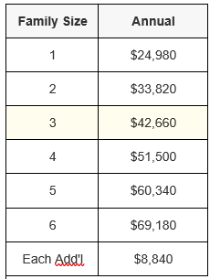
Competition Guidelines
- One scholarship award will be given in the amount of $1,000 to a low-income graduating senior who will be entering college in the fall of 2019.
- General family income: 200% federal poverty guidelines. Income verification is not required.
- Student must live in the New River Valley.
- Consideration should be given to academic achievements, extra-curricular, and community service activities.
- Scholarship funds are to be used for educational expenses at the college of student’s choice.
- School may nominate more than one student.
Entry Requirements:
- If you would like to nominate a student, please complete the nomination form summarizing the nominee’s accomplishments and send to:
Scholarship Award Committee
New River Community Action
1093 East Main Street, Radford, VA 24141
Fax: (540) 633-2585
Email: nrca@nrcaa.org (preferred)
- The nomination form should include the names, addresses and telephone numbers of the student, parent(s) or guardians(s), school and name of guidance counselor nominating the student.
- For more information or clarification, please contact Sheila West at (540) 633-5133 ext. 415.

______________________________________________________________________

Nominator Information
Name of Guidance Counselor: Click here to enter text.
School Name: Click here to enter text.
School Address: Click here to enter text.
Email: Click here to enter text.
Phone: Click here to enter text.

______________________________________________________________________

Nominee Information
Student Name: Click here to enter text.
Parent or Guardian Name(s): Click here to enter text.
Street Address: Click here to enter text.
City, State, Zip: Click here to enter text.
Phone: Click here to enter text.
Email: Click here to enter text.
College Attending: Click here to enter text.
Summary of Nominee Accomplishments -
Academic Achievements: Click here to enter text.
Extra-curricular Activities: Click here to enter text.
Community Service Activities: Click here to enter text.
Other Comments or Circumstances for Consideration: Click here to enter text.

